Streaming Churn Analysis and Prediction
- Goal: predict which users are likely to cancel their subscription using behavioral and billing data.
- Tools: Python, PostgreSQL, psycopg2, SQLAlchemy, pandas, seaborn, matplotlib, DBeaver

- Database Design
The project uses a PostgreSQL database with 6 normalized tables; all connected via user_id foreign key. The database was designed to separate concerns clearly – user demographics, subscription info, engagement behavior, support history, billing, and churn labels are each stored independently.
  - Schema overview
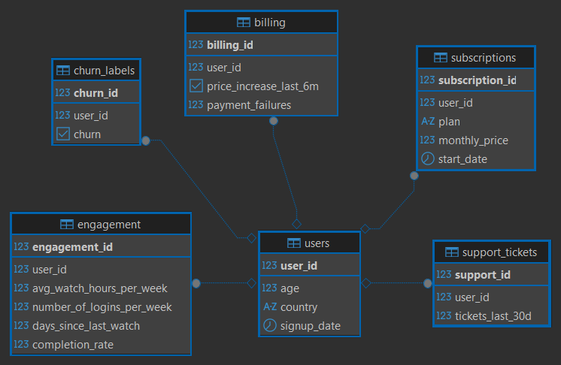
Figure 1 - DBeaver was used to make the schema visualization
Table | Columns
users | user_id (PK) · age (INT) · country (VARCHAR) · signup_date (DATE)
subscriptions | subscription_id (PK) · user_id (FK) · plan (VARCHAR) · monthly_price (NUMERIC) · start_date (DATE)
engagement | engagement_id (PK) · user_id (FK) · avg_watch_hours_per_week (NUMERIC) · number_of_logins_per_week (INT) · days_since_last_watch (INT) · completion_rate (NUMERIC)
support_tickets | support_id (PK) · user_id (FK) · tickets_last_6m (INT)
billing | billing_id (PK) · user_id (FK) · price_increase_last_6m (BOOLEAN) · payment_failures (INT)
churn_labels | churn_id (PK) · user_id (FK) · churn (BOOLEAN)

  - Connection Setup
The database connection is handled in a dedicated database.py file using psycopg2. Credentials are never hardcoded – they are loaded from an .env file using python-dotenv, keeping sensitive information out of the codebase.
database.py
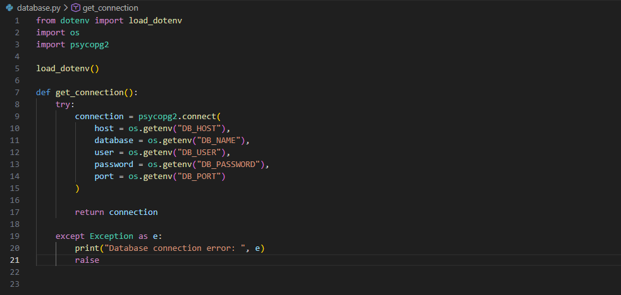
.env file
The .env file stores all credentials locally and is never committed to version control (added to .gitignore). It follows this structure:
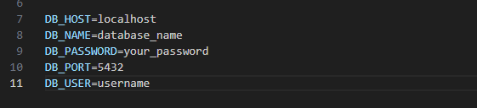
When loading data for EDA (Exploratory Data Analysis), the connection was upgraded to SQLAlchemy to avoid a pandas deprecation warning with raw psycopg2 connections. The same .env credentials were reused:
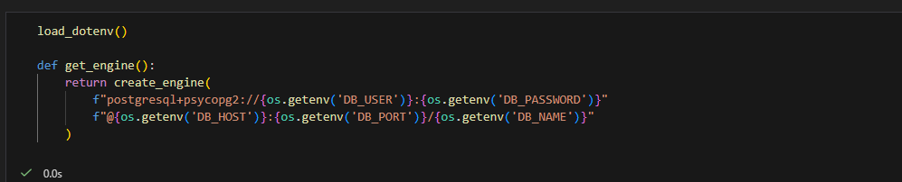
- Database Creation via Python
The entire database – both the table structure and the data – was created programmatically using Python. No SQL client or GUI tool was used. This makes the setup fully reproductible: anyone can clone the project, configure the .env file, and run a single script to have the complete database ready.
  - create_table()
The create_table() function runs a single SQL statement using psycopg2 that creates all 6 tables at once, using CREATE TABLE IF NOT EXISIST to make it safe to run multiple times without errors. It is called automatically at the start of main() before any data is inserted.
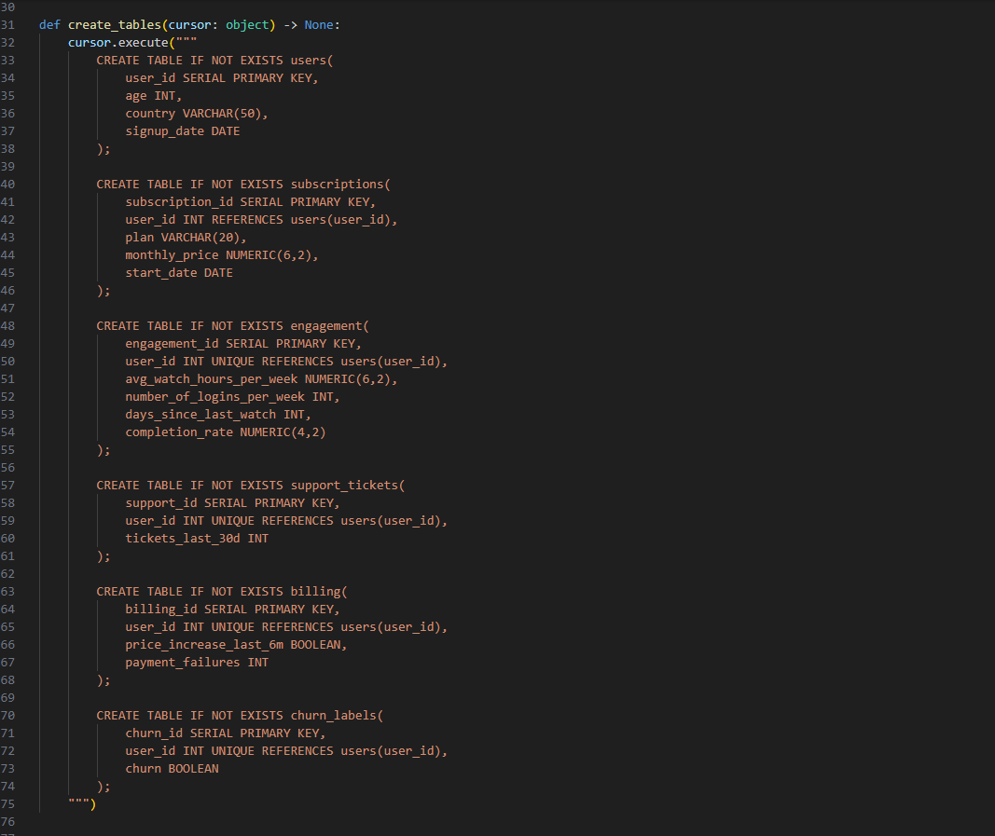
  - Execution Flow
The main() function orchestrates the full setup in order – connection, creating tables, seeding data, and committing – with a rollback on any error:
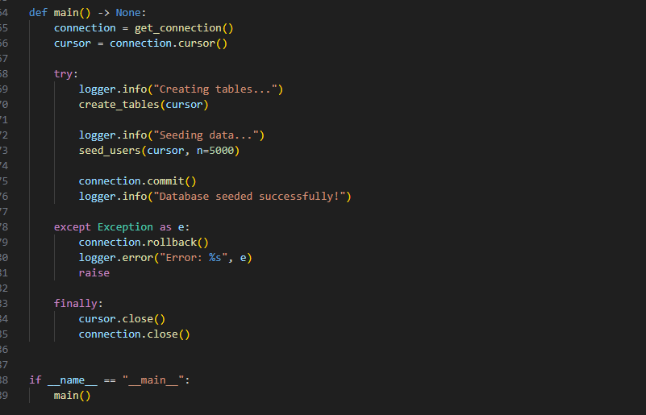
Wrapping everything in a single transaction means that if the seeder fails halfway through, no partial data is left in the database – the rollback ensures a clean slate.
- seed_database.py
The seeder script generates 5000 synthetic users and populates all 6 tables. It was iteratively improved throughout development, with several important bugs caught and fixed along the way.
  - How it works
- Generates user data (age, country, signup_date) for all n users first, collecting results in a list.
- Inserts all users in a single batch call using execute_values – much faster than inserting one row at a time.
- Retrieves all generates user_ids using RETURNING user_id, then builds related records for all 5 other tables.
- Insert each table’s data in one batch call.

  - Churn Label Logic
Churn is assigned probabilistically using a weighted score to avoid a purely deterministic label. A fully deterministic label would allow an ML model to simply memorize the rules rather than learn from the features.
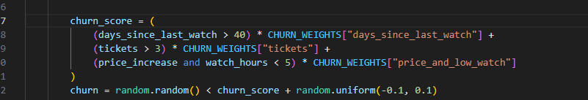
- Exploratory Data Analysis
EDA was conducted in a Jupyter Notebook using pandas, seaborn, and matplotlib. Data was loaded from PostgreSQL using SQLAlchemy and pd.read_sql, joining all 6 tables into a single flat dataframe on user_id.
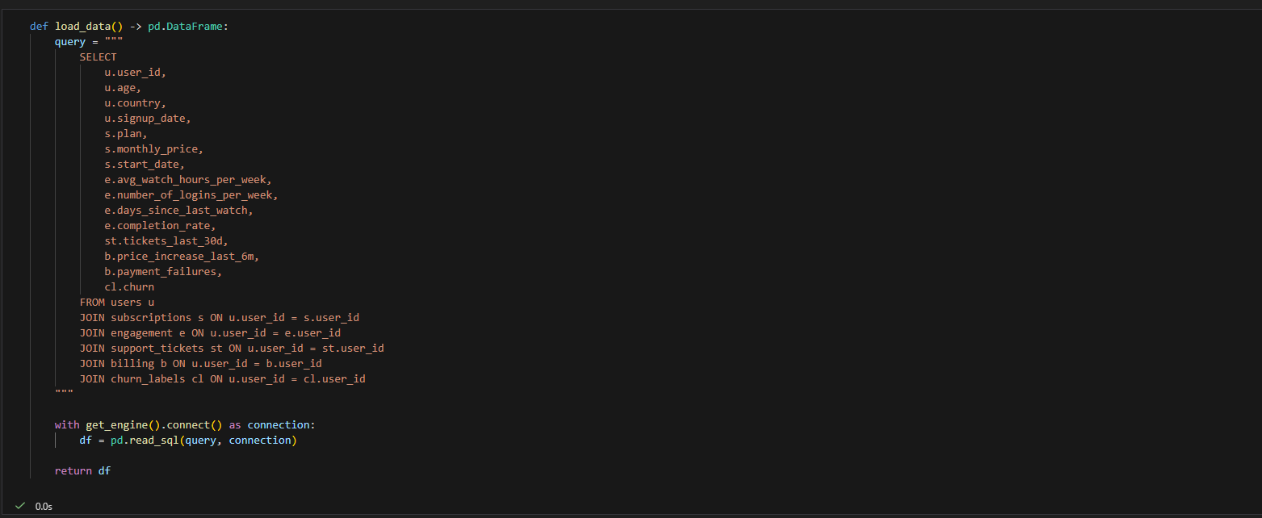
  - Date Column Type Conversion
After loading the data, the DATE columns (signup_date and start_date) were read as object dtype instead of datetime. This is a known behaviour when loading date columns via pd.read_sql – pandas does not automatically infer date types from PostgreSQL DATE fields. They were converted manually after loading:
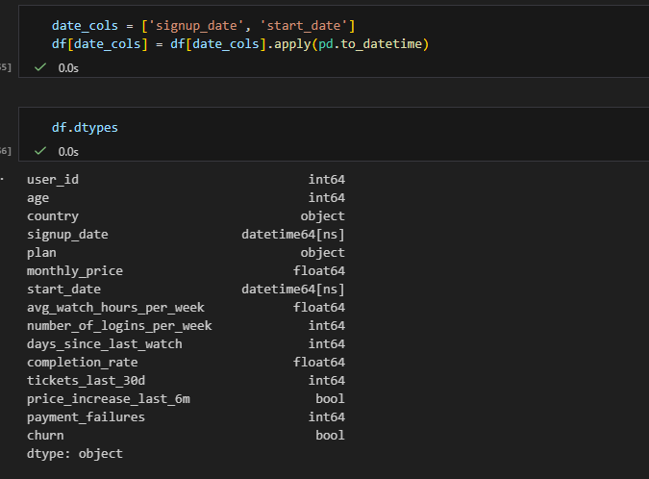
  - Churn Balance
The first thing checked was the class distribution of the churn label, since imbalanced classes require special handling in ML modeling.
Class | Count
Non-Churn (False) | 3,592 (72%)
Churn (True) | 1,408 (28%)

The 72/28 split is a healthy imbalance. When modeling, class_weight=’balanced’ and stratified k-fold cross validation will be used to handle it correctly. Evaluation will focus on F1-score, precision, and recall rather than raw accuracy.

  - Single variable analysis
Each feature was examined individually to understand its distribution before comparing against churn.
- All show flat, uniform distributions – expected given that the data was generated using random.uniform and random.randint.: Continuous features
- Evenly distributed across all 13 countries (~385 each) and all 3 plans (~1,667 each), as expected from random.choice.: Categorical features

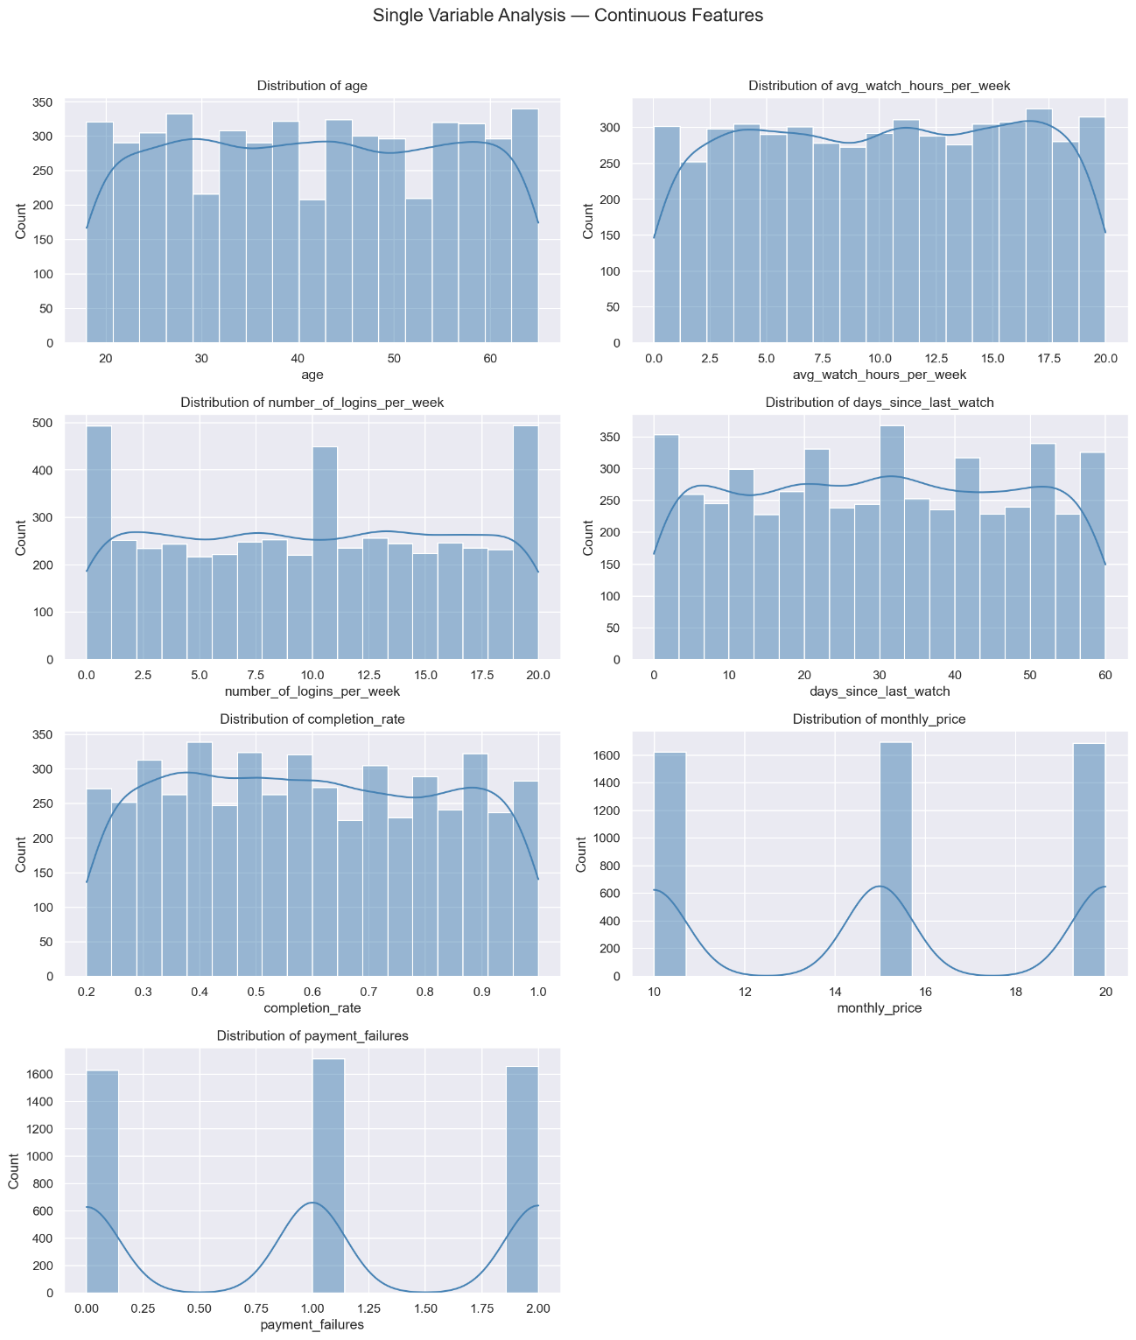
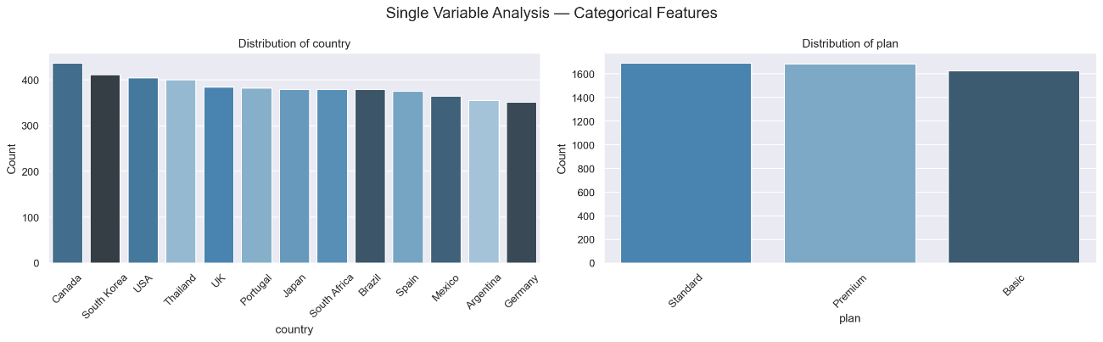
  - Multi-Variable Analysis
Multi-variable analysis compares each feature against the churn label to identify the strongest predictors. Three methods were used: box plots for continuous features, churn rate bar charts for categorical features, and a correlation heatmap.
Continuous Features vs Churn – Box Plots
Box plots were generated for each continuous feature split by churned vs non-churned users. The key finding was clear separation on days_since_last_watch, which is the strongest visual predictor – churned users had a noticeably higher median. All other features (age, watch_hours, logins, completion_rate, monthly_price, payment_failures) showed heavily overlapping distributions with no meaningful separation, indicating they are weak individual predictors on their own.
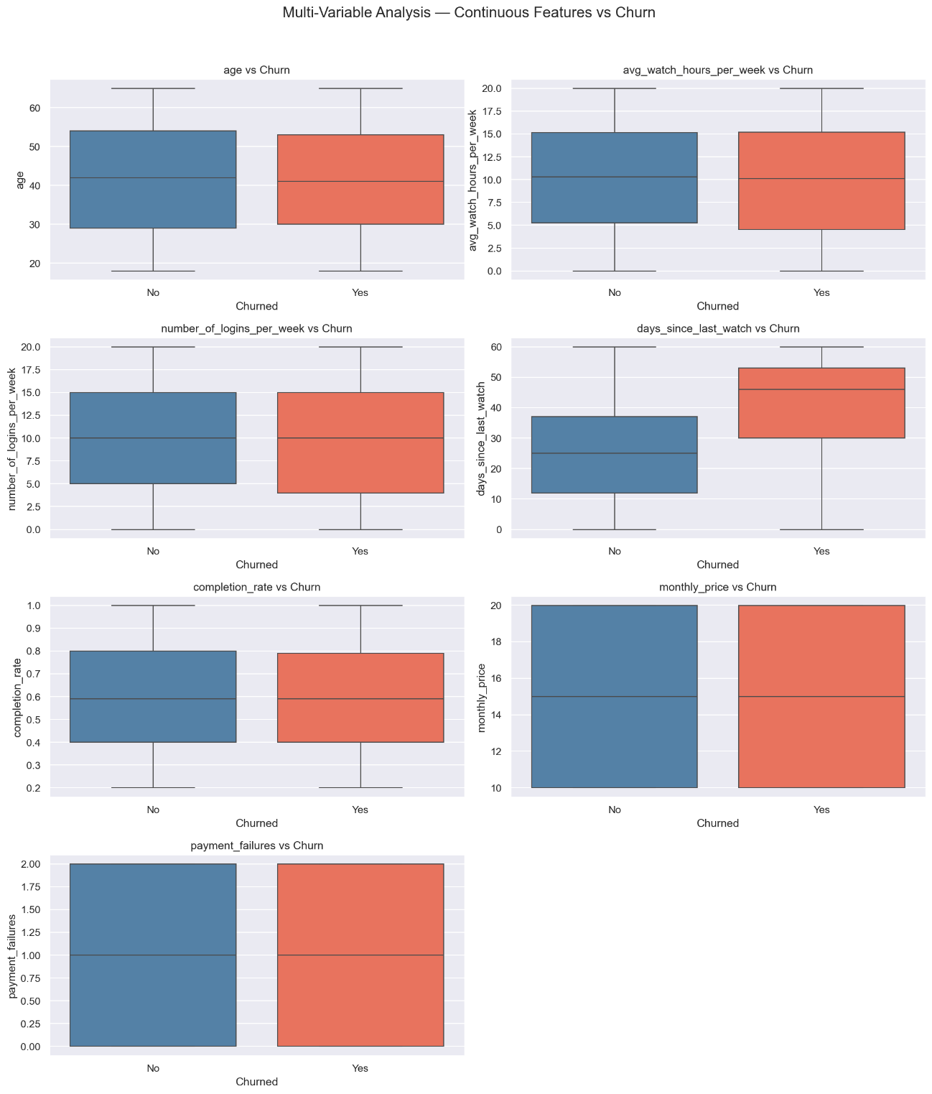
Categorical Features vs Churn – Churn Rate
Churn rate was calculated per group for country and plan, with the overall average (28.16%) shown as a reference line. Both features showed a near-identical churn rate than all overall average. This is expected since both were randomly assigned during data generation.
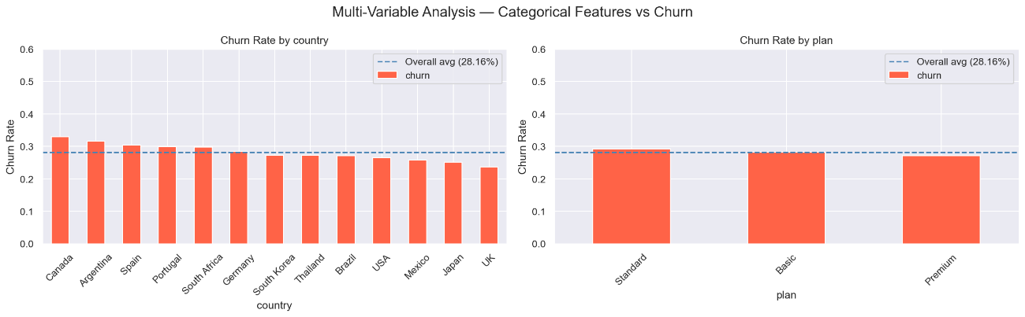
Correlation Heatmap and Feature Correlations
A Pearson correlation heatmap was generated across all numeric features including churn (encoded as 0/1). The correlation of each feature with churn, sorted by absolute strength, was:
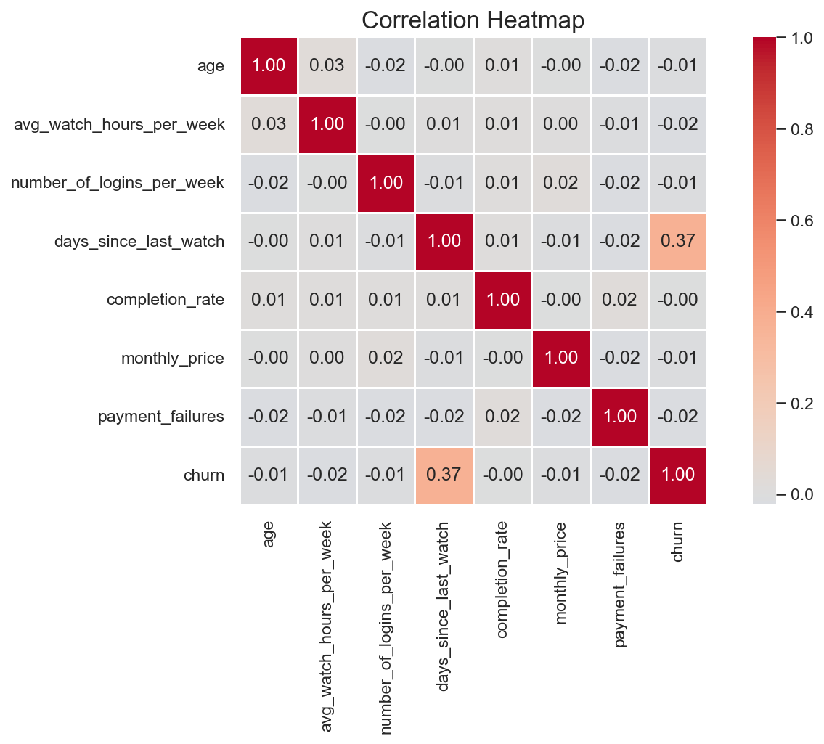
Feature | Correlation | Strengh
days_since_last_watch | +0.37 | Strong – dominant predictor
avg_watch_hours_per_week | -0.02 | Very weak
payment_failures | -0.02 | Very weak
number_of_logins_per_week | -0.01 | Negligible
age | -0.01 | Negligible
monthly_price | -0.01 | Negligible
completion_rate | ~0.00 | No correlation

Key Takeaways
- days_since_last_watch is by far the strongest predictor of churn (r = +0.37) – users who have not watched recently are significantly more likely to churn. This directly reflects the churn label design.
- All other features show near-zero correlation with churn individually. This does not mean they are useless – non-linear models like Random Forest and XGBoost can capture interaction effects between features that Pearson correlation misses.
- country and plan show no predictive power, as expected from random assignment. In a real-world dataset these could be meaningful segments.
- The low correlation between most features with churn makes this a realistic ML challenge – the model will need to learn from combinations of features rather than any single dominant signal.

- Feature Engineering
Feature engineering transforms raw data into more informative inputs for ML models. The goal is to make patterns that are hard for a model to discover on its own more explicitly, and to encode domain knowledge directly into the features. After this step, the dataset grew from 15 columns to 31, ready for modeling.
  - New Features Created
tenure_days
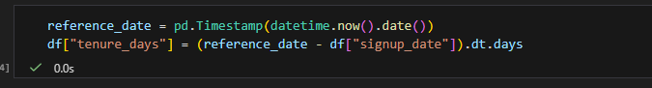
How long has the user been subscribed to in days. This is exactly why the date columns were converted to datetime earlier – without that conversion this calculation would fail with a TypeError. Tenure captures loyalty: long-standing users tend to be stickier, while newer users may still be evaluating the service. It also lets the model detect early churn patterns that raw dates cannot express.
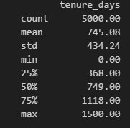
engagement_score
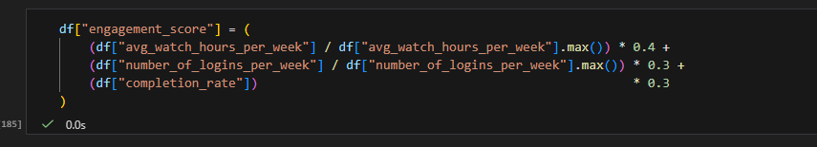
A weighted composite of three engagement signals: watch hours (40%), logins (30%), and completion rate (30%). Watch hours are weighed most heavily as the most direct measure of active usage. Instead of asking the model to independently learn the relationship between three separate correlated features and churn, this gives it one clean, pre-combined signal. The score ranges from 0 to 1, with a mean of 0.53.
is_inactive
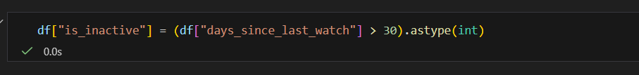
A binary flag (0/1) for users who have not watched anything in over 30 days. This directly encodes the strongest signal from the multi-variable analysis – days_since_last_watch had the highest correlation with churn at r=+0.37. Converting it to a binary threshold makes the decision boundary explicit: Logistic Regression in particular benefits from this because it might otherwise struggle to find the right cutoff on a continuos variable on its own. 49% of users are flagged as inactive.
